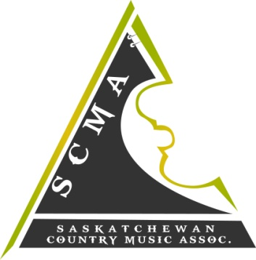

2016 S.C.M.A. AWARDS
April 22, 23, 24 - 2016
SHOWCASE APPLICATION
YOUTH SHOWCASE

NAME ___________________________________________________________________________________

MAILING ADDRESS ________________________________________________________________________

CITY___________________________ PROV. _______________________ P.C _________________________

PHONE # ____________________________ S.C.M.A MEMBERSHIP # _____________________________

EMAIL : __________________________________________________________________________________

Age: YOUTH (17 years or younger) ____________________

Have you showcased at the S.C.M.A's before? Yes ___________ No______________

If Yes, WHICH year? ___________________ ( you may NOT showcase 2 consecutive years )

-Please submit a promo-pack (picture/ MP3 of two songs / brief biography )
*preference will be given to those with original material

-ALL performers, including band members, must be members of the S.C.M.A.
*membership forms are available for download at www.scma.sk.ca

-ALL performers must have live accompaniment- NO taped music.

-We appreciate and thank all who apply, but submission of promo-pack does NOT
guarantee a spot. If you are not chosen, you may be put on a waiting list in the event
that someone cancels.

SUBMIT APPLICATION OR QUESTIONS VIA EMAIL: scmayouthshowcase@gmail.com
***DEADLINE FOR SUBMISSIONS IS February 26th, 2016. APPLICANTS WILL BE NOTIFIED OF RESULTS BY MARCH 18th, 2016.
The YOUTH SHOWCASE will be held Saturday April 23rd, 2016 after the Industry Awards and Brunch at 12:15.

