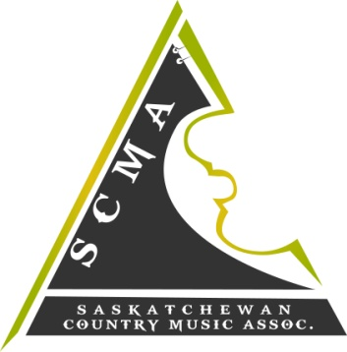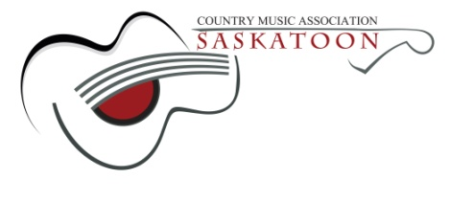

Hello S.C.M.A Members!
The 2016 S.C.M.A Host Committee would like to invite our members to apply for a performance spot at the 2016 "New Artist Showcase" during the Awards Weekend April 22nd – 24th in Saskatoon, Sk.
This is a fantastic opportunity for new, "up and coming" Saskatchewan artists to showcase their talent! This showcase will be held on April 23, 2016 - 10pm at The Longbranch Good Times Beverage Company, Saskatoon, SK.
Apply by completing and returning the attached application form along with the requested materials. The deadline for submissions is Friday February 26th, 2016 and the decisions will be made by March 18, 2016.
Best of luck to all applicants!
Sincerely,
2016 S.C.M.A New Artist Showcase Committee

